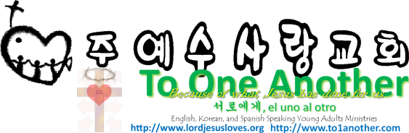
Wise Living
Pastor Yoo Nam Kang
Luke 12:16-21
March 10, 2013
Scriptures in New Living Translation

Luke 12:16-21
16 Then he told them a story: “A rich man had a fertile farm that produced fine crops. 17 He said to himself, ‘What should I do? I don’t have room for all my crops.’ 18 Then he said, ‘I know! I’ll tear down my barns and build bigger ones. Then I’ll have room enough to store all my wheat and other goods. 19 And I’ll sit back and say to myself, “My friend, you have enough stored away for years to come. Now take it easy! Eat, drink, and be merry!”’ 20 “But God said to him, ‘You fool! You will die this very night. Then who will get everything you worked for?’ 21 “Yes, a person is a fool to store up earthly wealth but not have a rich relationship with God.”

1. Live recognizing the brevity of life
1 Corinthians 7:29-31
29 But let me say this, dear brothers and sisters: The time that remains is very short. So from now on, those with wives should not focus only on their marriage. 30 Those who weep or who rejoice or who buy things should not be absorbed by their weeping or their joy or their possessions. 31 Those who use the things of the world should not become attached to them. For this world as we know it will soon pass away.

2. Live (be) satisfied with what you have
Hebrews 13:5
5 Don’t love money; be satisfied with what you have. For God has said, “I will never fail you. I will never abandon you.”
Psalms 23:1
The Lord is my shepherd; I have all that I need.
Luke 9:16-17
16 Jesus took the five loaves and two fish, looked up toward heaven, and blessed them. Then, breaking the loaves into pieces, he kept giving the bread and fish to the disciples so they could distribute it to the people. 17 They all ate as much as they wanted, and afterward, the disciples picked up twelve baskets of leftovers!

3. Live recognizing the coming judgment
Hebrews 9:27
And just as each person is destined to die once and after that comes judgment,
Three absolute things that will happen in life
- You will live
- You will die
- You will be judged
Philippians 3:7-9, 13-14
7 I once thought these things were valuable, but now I consider them worthless because of what Christ has done. 8 Yes, everything else is worthless when compared with the infinite value of knowing Christ Jesus my Lord. For his sake I have discarded everything else, counting it all as garbage, so that I could gain Christ 9 and become one with him. I no longer count on my own righteousness through obeying the law; rather, I become righteous through faith in Christ. For God’s way of making us right with himself depends on faith.
13 No, dear brothers and sisters, I have not achieved it, but I focus on this one thing: Forgetting the past and looking forward to what lies ahead, 14 I press on to reach the end of the race and receive the heavenly prize for which God, through Christ Jesus, is calling us.

